Numerical Relativity

Exercise-1

Demetry Alfalahat

ID: 922365

Generally: We are studying Sod Shock Tube problem and the Tolman-Oppenheimer-Volkoff (TOV) equation evolution using Einstein tool kit.

Exercise 2-1

Sod problem (A method stimulates any Hydrodynamical system on a computer. This case represents a 1-Dimensional tube): We considered the non-relativistic case for an ideal fluid () applying the HLLE (Approximate Riemann solver). It has been found as the grid resolution increases, the stimulated rest mass density converges toward the exact solution (Figure 1). These distortions are related to the second and first order error for the rarefaction and the shock wave respectively as it was shown mathematically in the “minmod” slop limiter method. One can see for the rarefaction distortion diminish as we increase the resolution more than the shock.

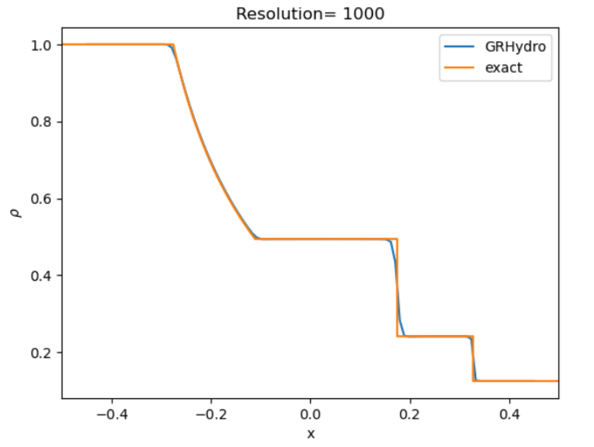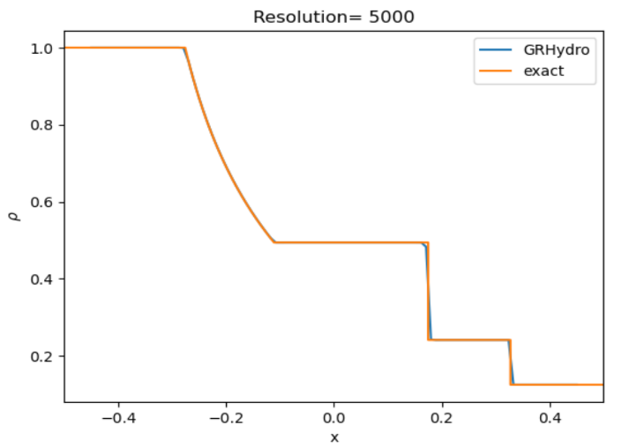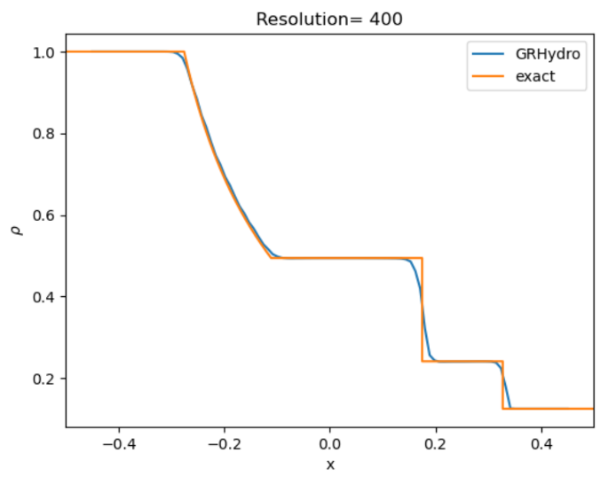

Figure 1: Applying the simulation using with three resolutions = 400, 1000, 5000 for the x-axis grid. It shows some distortion from the exact in the 400 and this distortion almost disappear in the 5000 resolution. The 3 jumps represent the rarefaction, contact discontinuity and the shock wave respectively from the plots regarding the 3 Eigenvalues for a hydrodynamical system.

Exercise 2-2

**TOV evolution of the maximum rest-mass density of a stable star: We are studying the evolution regarding TOV equations using Marquina (another Approximate Riemann solver) with the polytropic form of the TOV equation (). Where K=100 and** . Data from Cactus simulation in Figure 2 shows oscillation in the density due to the low resolution as shown for the green line. For the exact relation, we are expecting to see no change with the density through the evolution with time. Increasing the resolution would give a more stable function as we see for and .

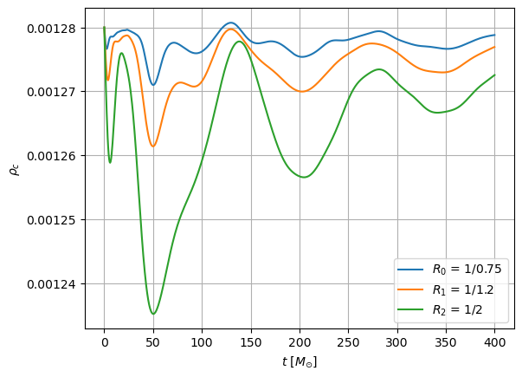

Figure : The maximum rest-mass density vs the evolution time in unit of solar mass. R stands for the Resolution used in the program for the 3 dimensions (x,y,z). Increasing the resolution give more stable function.

**We can see the effect due to the resolutions using the mesh representation in Figure 3. The higher resolution we have the clearer image. Compare in Figures 2 & 3 for better understanding.**

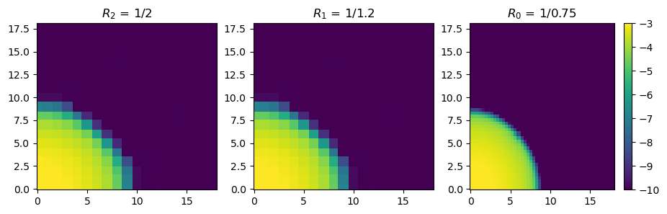

Figure : 2-Dimensional (x and y axes) representation of a stable star. Zero on both axes shows the center of the star where the density is the highest and get lower as we move out.

Exercise 2-3

**MoL::ODE Method = "rk4" :**

a numerical technique used to solve ordinary differential equations (ODEs) after been transformed from Partial Differential Equations (PDEs). MoL stands for Methods of lines which is a technique for solving [partial differential equations](https://en.wikipedia.org/wiki/Partial_differential_equations) (PDEs) in which all but one dimension is discretized. By reducing a PDE to a single continuous dimension and the computer will solve them as if they are ODEs.

**GRHydro::recon_method = "ppm" :**

ppm stands for Piecewise Parabolic method which is another way to reconstruct a function as in the TOV evolution. (Considered as an alternative for the minmod method as it was used in Sod problem)

**GRHydro::riemann solver = "HLLE":**

Harten-Lax-van Leer-Einfeldt (HLLE) which is an approximate Riemann solver. It is used to compute numerical fluxes at cell interfaces.

**For ML_BSSN Block:** It indicates you’re using the McLachlan implementation of the BSSN equations. This block maintains Gauge Conditions (Avoiding singularities with distortions and don’t need expensive computations.

**ML_BSSN::harmonicN = 1 and ML_BSSN::harmonicF = 2.0 :**

Both refers to harmonic slicing condition where we used for our simulation. It is called the 1+log slicing condition due to the result which results from implementing the ADM equations.

**ML_BSSN::ShiftGammaCoeff = 0.75 :**

Gamma Driver shift condition:

Where and that’s why we call it Gamma shift driver as it’s controlled by this shift. Also, 0.75 = ¾ which is the value from the condition.